Magnetic Field Measurement Apparatus – Helmholtz Coils
Aim
1. To study the variation of the magnetic field with distance along the axis of a circular current carrying coil.
2. To study the principle of superposition of magnetic field, and in particular to study the axial variation of the magnetic field due to both the coils when the distance between them is equal to the radius of the coils.

Apparatus

Magnetic Field Measurement (MFM), Helmholtz coils, Sensor for Field Measurement.
Theory

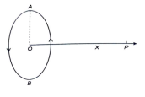Figure 1
Current-carrying conductors produce a magnetic field around them. The study of their correlation, distribution of its strength in space around the conductor, and the effect of two current-carrying conductors placed closely are of primary interest. The present set-up aims toward this when the conductors are in the form of two coaxial circular coils.
We know, the intensity of the magnetic field on the basis of Biot Savart's law at a point ‘P’, lying on the axis of a circular coil ‘AB’ of radius ‘a’ having ‘n’ turns at a distance ‘d’ from the centre ‘O’ of the
coil in S.I. units, is given by
_{4�� .}2��������^{ଶ}
_{�� =} ��଴
I is the current flowing through the coil
(��^{ଶ} + ��^{ଶ})^{ଷ}_{ଶ} Tesla
��଴ is the permeability of the free space, which is equal to 4π x 10 H/m The units of B are Tesla or Wb/m²
The direction of the magnetic intensity at P is along OP produced if the current flows through the coil in the anti-clockwise direction as seen from P. If the direction of the current is clockwise the field at P is along PO.
The value of the magnetic intensity is maximum at the centre O of the coil and is given by _{�� =} ��଴
_{4�� .}2������
_{��=}��଴����
_{2��} Tesla
Or
_{�� =} 4�� x 10ି଻���� x 10^{ସ}
_{2��} Gauss
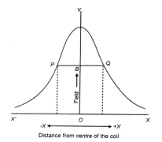
If we move away from O towards the right or left,
the intensity of the magnetic field decreases. A
graph showing the relation between the intensity of
the magnetic field B and the distance x is given in
Fig. 2. The curve is first concave towards O but the
curvature becomes less and less, quickly changes
sign at P and Q and afterwards becomes convex
towards O.
It can be shown that the points of inflexion P or Q
where the curvature changes in its sign lie at
_{distances} ௔ଶfrom the centre. Hence the distance
between P and Q is equal to the radius of the coil. If a pair of coaxial coils is separated by a distance
Figure 2
equal to the radius of the coils and they carry current in the same sense, then the magnetic field around the point midway between them will be uniform. The decrease in the field due to one coil will be compensated by the increase in the field due to the other.

Set-up Procedure

To study the axial variation of the magnetic field due to a single coil, calculate the radius of the coil and to study the superposition of the field when the distance between the coils is equal to their radius, proceed as follows:
(1) Connect the Sensor Cable (3-pin) to the sensor socket and Coil Cable (4-pin) to the coils socket. (2) Switch ‘ON’ the main's power.
(3) Turn the current adjusting knob anti-clockwise to the minimum position; so that the current is reduced to 0.
(4) Keep the sensor stand pointer at 60 cm and adjust the zero of Gaussmeter with ‘ZERO ADJ’. knob.
(5) Put the ‘COIL’ knob to Position 1 so that COIL 1 is connected to the current source. Adjust the current to say 250 mA.
(6) Note down the magnetic field from 60 cm to 14 cm at an interval of 1 cm along the axis of the coils by shifting the position of the sensor stand.
(7) Fix the position of COIL 2 at a distance of 11.2 cm from COIL 1 i.e., equal to the radius of the coils.
(8) Put the coil knob to Position 2, so that COIL 2 is connected to the current source. Keep the current same and note down the magnetic field from 60 cm to 14 cm again at an interval of 1 cm.
(9) Put the coil knob to Position 3, i.e., ‘BOTH’, COIL 1 & COIL 2 will be connected to the source. Now again, note down the readings from 60 cm to 14 cm.
Draw the graphs between distance and magnetic field due to COIL 1, COIL 2 and BOTH along the axis of coils as shown in Fig. 3. Note that in Fig 3, the values used is different than the experimental values that you observe.
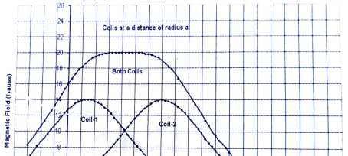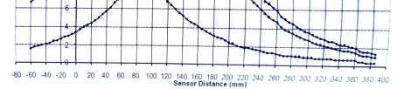Figure 3: Variation of the magnetic field for individual coils and both the coils
Observations
1. Position of coil 1 = 0 cm.
2. Position of coil 2 = 11.2 cm 3. Distance between the coils = 11.2 cm 4. Length of sensor rod = 26.5 cm 5. Current in the coils = 250 mA
S. No. Sensor Stand Position
(cm)
Sensor position (Sensor Stand Pos. – 26.5cm) (cm)
Magnetic Field (Gauss)
Coil 1 Coil 2 Both Coils

Result
1. The profile of the magnetic field with distance along the axis of circular coils carrying current is plotted on a graph.
2. Principle of superposition of magnetic field is verified.
a. The magnetic field profile that when the current is flowing through both the coils, the magnetic field at any point is the ________ of the magnetic fields due to Coil 1 and Coil 2 i.e., when the current is following individually.
b. The magnetic field is _________ over a large space when the distance between the two current-carrying coils is equal to the radius of the coils.
Discussion
Discuss on the errors that may arise in this experiment.

